**Printing Command Options**

To see all Node command line flags for any version of Node, execute **node --help** and view the output.

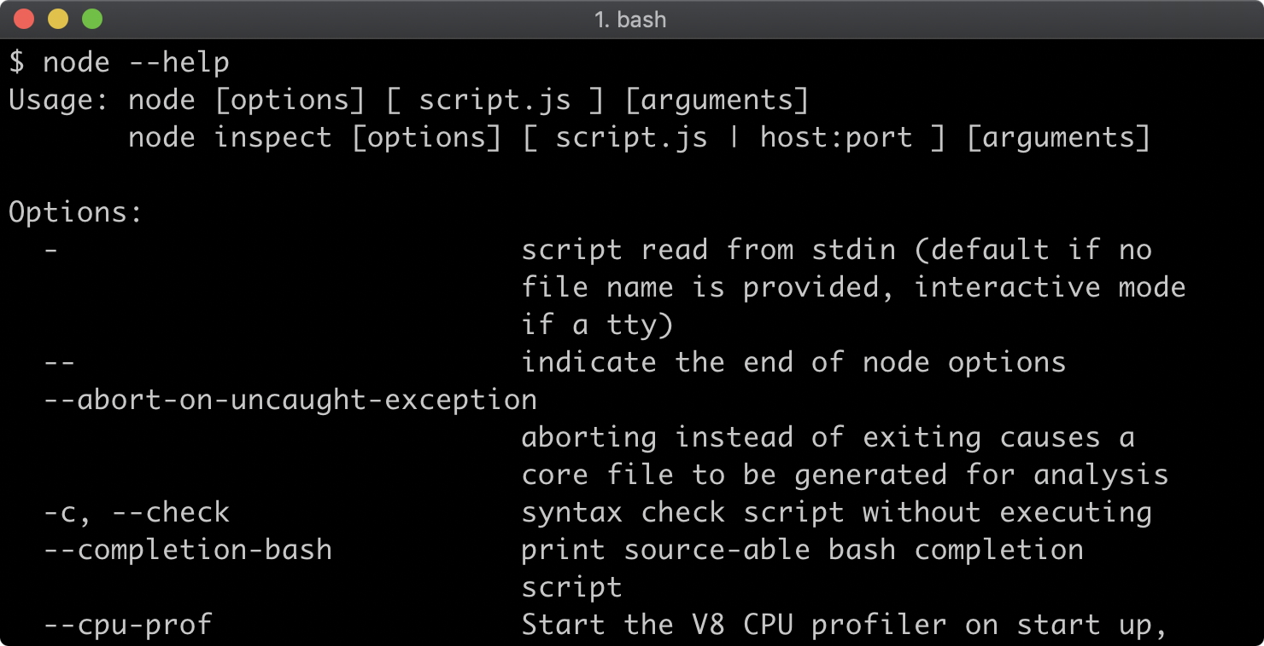

Beyond the Node command line flags there are additional flags for modifying the JavaScript runtime engine: V8. To view these flags run **node --v8-options**.

